VAISHNAVI E 231901059

**EX.NO:2B DATE:**

# SHELL SCRIPT

**AIM:** To write a Shell script to test given year is leap or not using conditional statement

**PROGRAM:**

echo "Enter a year:" read year

if [ $(expr $year % 4) -eq 0 ]; then if [ $(expr $year % 100) -eq 0 ]; then if [ $(expr $year % 400) -eq 0 ]; then

echo "$year is a leap year"

else

echo "$year is not a leap year" fi

else

echo "$year is a leap year" fi else

echo "$year is not a leap year" fi

**INPUT & OUTPUT:**

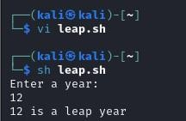

**RESULT:** Hence, finding leap year using shell script is executed successfully.

**CSE-CYBER SECURITY**